Cat abundance

Cats were detected on transects at 24 of 53 sites. Forty-four individual cats were detected on cameras at 25 of 48 sites. Cats were detected on camera but not transects at 18.9% of sites (n=10), and cats were detected by transect but not camera at 12.5% of sites (n=6, plus an additional 3 sites that did not receive camera deployments). Combined between both methods, cats were detected at 34 of 53 sites. There was little variation in counts among sites, with one or no cats counted on transects at 81.1% of sites (n=43), and more than 3 cats counted on transects at only 5.6% of sites (n=3). The most cats counted on transects at a site over the course of the study was 8 (n=1). On cameras, 77.1% of sites (n=37) had either one or no individuals detected, and the most individuals detected at a site was 4 (n=2).

Abundance models yielded similar results between the two data sets. For transect data, all three quadratic response models received substantially more support than linear response models (Table 6). A quadratic response to impervious surface was the best-supported urbanization response in transect models. For camera models, a quadratic response to canopy cover received the most support (Table 7) though linear responses to canopy cover and impervious surface also received substantial support (AICc < 2, Burnham and Anderson 2003).

Additional models including the best-supported urbanization measure were compared for each dataset to examine the influence of human demographic variables on cat abundance. For both model sets, the best supported model was the quadratic form of the urbanization variable plus percentage of the site’s census tract population with at least a high school degree (transects, Table 8; cameras, Table 9). For both model sets, there was a negative relationship between cat abundance and educational attainment and a negative quadratic relationship between cat abundance and urbanization (Table 10). The linear term of impervious surface was positively related to cat abundance in transect models, and the linear term of canopy cover was negatively related to cat abundance in camera models (Table 10).

Predicted cat abundance measures from candidate models were used to find model-averaged estimates of cat density at transect sites. Average density across sites was 4.97 cats/ha and ranged from 0.11 to 20.21 cats/ha. Because transect and camera methods detect cats at different scales and camera-derived abundance estimates are not spatially explicit, no direct comparison can be made between transect and camera estimates. However, plots model-averaged cat abundance estimated from both methods are shown in Figure 2a and b.

Table 2. Candidate models of the influence of urbanization on cat abundance ranked by degree of support. K is the number of estimated parameters. AICcwt is the model’s AICc weight.

|  |  |  |  |  |  |  |
| --- | --- | --- | --- | --- | --- | --- |
| Model λ formula | K | AICc | ΔAICc | AICcwt | Log-likelihood | Model set |
| imp + imp2 | 8 | 456.42 | 0 | 0.61 | -217.50 | Transect |
| density + density2 | 8 | 457.65 | 1.23 | 0.33 | -218.00 | Transect |
| can + can2 | 8 | 461.41 | 4.99 | 0.05 | -219.99 | Transect |
| can | 7 | 466.55 | 10.13 | 0.00 | -223.89 | Transect |
| imp | 7 | 467.92 | 11.50 | 0.00 | -224.54 | Transect |
| density | 7 | 468.46 | 12.04 | 0.00 | -224.74 | Transect |
| can + can2 | 6 | 691.20 | 0 | 0.35 | -338.58 | Camera |
| can | 5 | 691.93 | 0.73 | 0.24 | -340.25 | Camera |
| imp | 5 | 692.84 | 1.64 | 0.15 | -340.71 | Camera |
| density | 5 | 693.40 | 2.20 | 0.12 | -340.99 | Camera |
| imp + imp2 | 6 | 693.65 | 2.45 | 0.10 | -339.80 | Camera |
| density + density2 | 6 | 695.66 | 4.45 | 0.04 | -340.80 | Camera |

Table 3. Candidate models of the influence of urbanization and human demographics on cat abundance ranked by degree of support. K is the number of estimated parameters. AICcwt is the model’s AICc weight.

|  |  |  |  |  |  |  |
| --- | --- | --- | --- | --- | --- | --- |
| Model λ formula | K | AICc | ΔAICc | AICcwt | Log-likelihood | Model set |
| imp + imp2 + eduHS | 9 | 453.27 | 0 | 0.48 | -215.54 | Transect |
| imp + imp2 + eduC | 9 | 455.93 | 2.66 | 0.13 | -216.87 | Transect |
| imp + imp2 + inc | 9 | 456.38 | 3.11 | 0.10 | -217.10 | Transect |
| imp + imp2 | 8 | 456.42 | 3.14 | 0.10 | -218.57 | Transect |
| imp + imp2 + marred | 9 | 456.42 | 3.15 | 0.10 | -217.12 | Transect |
| imp + imp2 + age | 9 | 459.00 | 5.72 | 0.03 | -218.40 | Transect |
| can + can2 + eduHS | 7 | 690.90 | 0 | 0.32 | -337.05 | Camera |
| can + can2 | 6 | 691.20 | 0.30 | 0.28 | -338.58 | Camera |
| can + can2 + eduC | 7 | 692.83 | 1.93 | 0.12 | -338.01 | Camera |
| can + can2 + marred | 7 | 693.46 | 2.56 | 0.09 | -338.33 | Camera |
| can + can2 + age | 7 | 693.87 | 2.97 | 0.07 | -338.54 | Camera |
| can + can2 + inc | 7 | 693.90 | 3.00 | 0.07 | -338.55 | Camera |

Table 4. Beta and standard error estimates of the influence of urbanization and human demographic variables on cat abundance. The urbanization measure (Urban) used in transect models was impervious surface. The urbanization measure used in camera models was canopy cover. Urbanization variable β and SE estimates are averaged by model weight. eduHS refers to the percent of a census tract population with at least a high school diploma.

|  |  |  |  |  |  |  |  |  |
| --- | --- | --- | --- | --- | --- | --- | --- | --- |
|  | Urban | |  | Urban2 | |  | eduHS | |
| Model set | $$\overline{\text{β}}$$ | $$\overline{\text{SE}}$$ |  | $$\overline{\text{β}}$$ | $$\overline{\text{SE}}$$ |  | $$\text{β}$$ | SE |
| Transect | 0.94 | 0.36 |  | -0.91 | 0.31 |  | -0.44 | 0.17 |
| Camera | -0.26 | 0.25 |  | -0.42 | 0.27 |  | -0.30 | 0.17 |

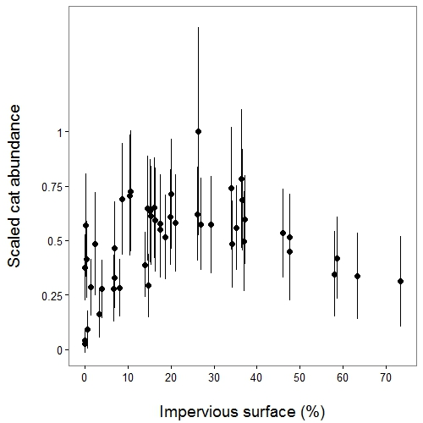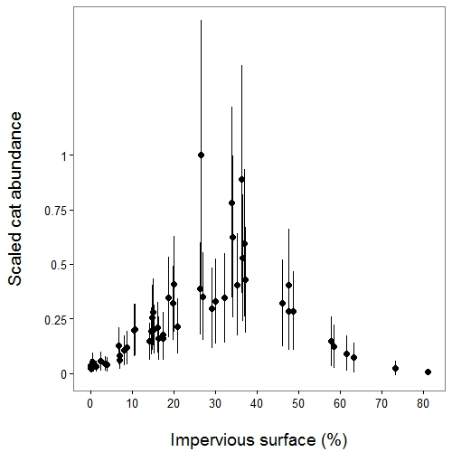

a

b

Figure 2. Model-averaged estimates of cat abundance scaled by the highest value and plotted by impervious surface percentage. Error bars are model-averaged standard errors. (a) Transect-derived estimates and (b) camera-derived estimates.

Burnham, K.P., Anderson, D.R., 2003. Model selection and multimodel inference: a practical information-theoretic approach. Springer Science & Business Media.